Lab - Use Steganography to Hide Data
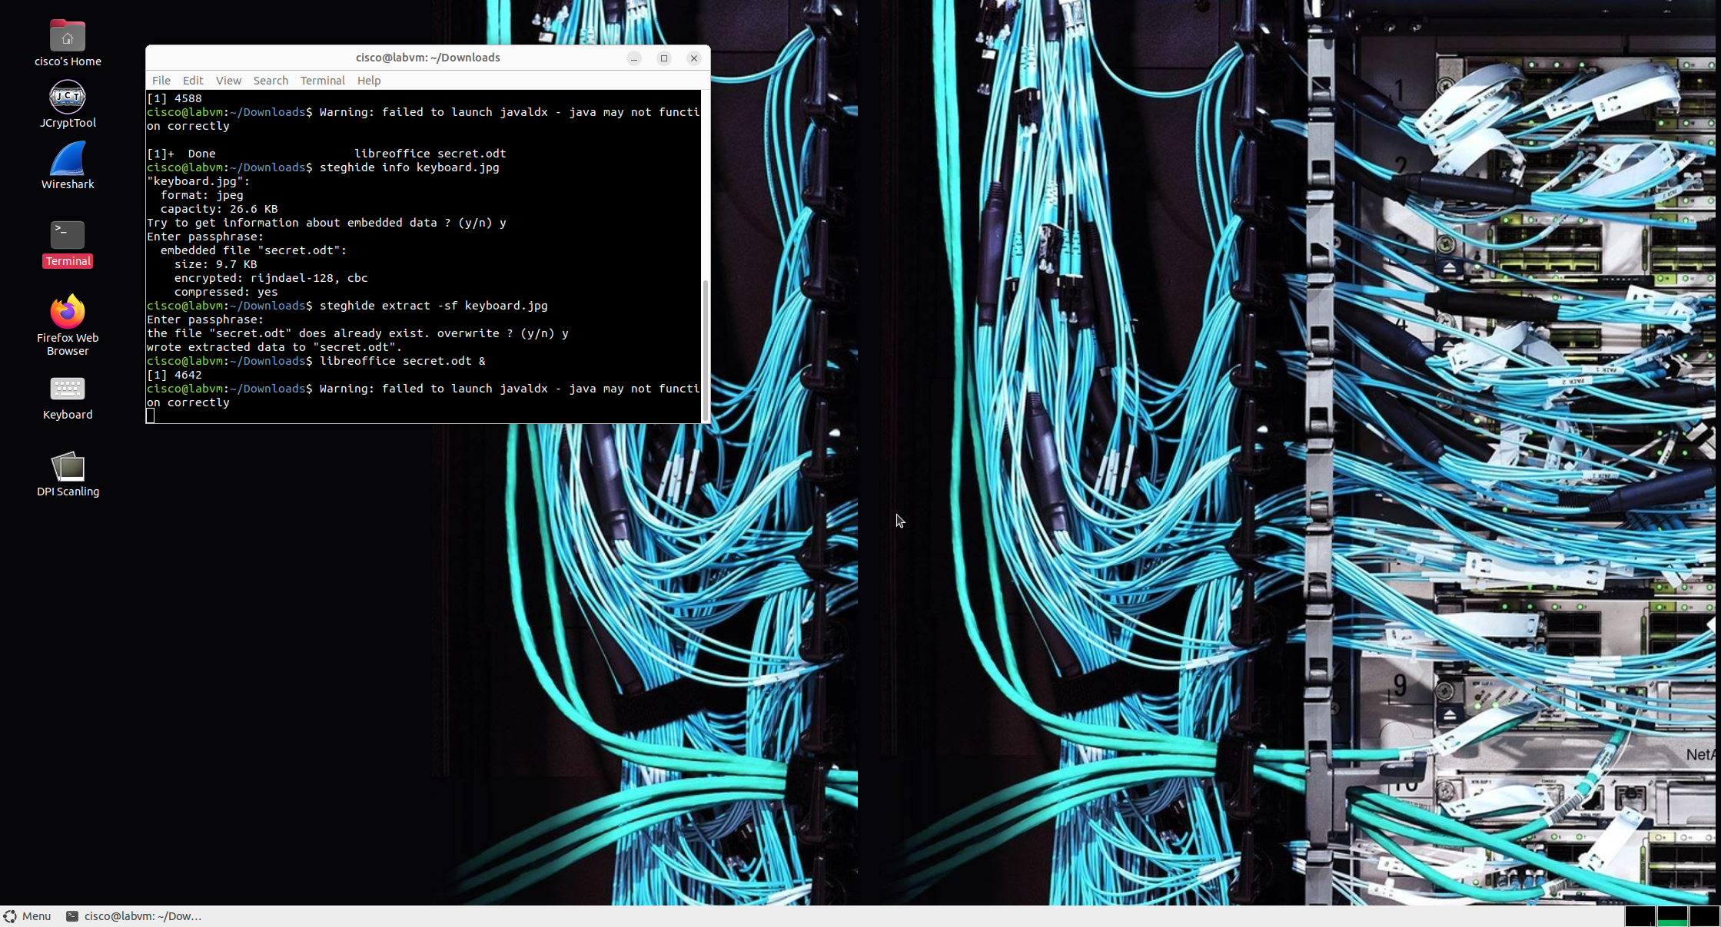

Objectives
Use steganography to hide a document within a JPEG file.

Background / Scenario
The advantage of steganography over cryptography is that the secret message does not attract any special attention. No one would ever know that a picture contained a secret message by viewing the file either electronically or in hardcopy. In this lab, you will use Steghide, an open-source steganography program, to hide a data file within an image file.

Required Resources
PC with the CSE-LABVM installed in VirtualBox

Instructions

Step 1: Open a terminal window in the CSE-LABVM.
a. Launch the CSE-LABVM.
b. Double-click the Terminal icon to open a terminal.

Step 2: Review the files that will be used for steganography.
a. Enter the cd Downloads/ command to change to the Downloads directory, and then list the contents of the directory.
cisco@labvm:~$ cd Downloads/
cisco@labvm:~/Downloads$ ls -l
total 472
drwxr-xr-x 8 cisco cisco 4096 Jan 27 01:30 jcryptool
drwxrwxr-x 3 cisco cisco 4096 Mar 18 18:11 john
-rw-rw-rw- 1 cisco cisco 455357 Mar 22 16:10 keyboard.jpg
drwxrwxr-x 6 root root 4096 Mar 18 17:46 lynis
-rw-rw-r-- 1 cisco cisco 9912 Mar 22 16:13 secret.odt
cisco@labvm:~/Downloads$
You will hide the contents of the secret.odt file inside the keyboard.jpg file.
b. Enter the libreoffice secret.odt & command to open the "secret.odt" file in LibreOffice.
cisco@labvm:~/Downloads$ libreoffice secret.odt &

Question:
What is the message in the secret.odt?
The secret document

Type your answers here.
c. Click File > Exit LibreOffice to quit LibreOffice and close the file.
d. In the terminal window, press Enter to get a new command prompt, and the enter command gimp keyboard.jpg & to open the "keyboard.jpg" file in GIMP.
cisco@labvm:~/Downloads$ gimp keyboard.jpg &
e. Click File > Quit to quit GIMP and close the file.
f. In the terminal window, press Enter to get a new command prompt.

Step 3: Use Steghide to embed the content of the secret.odt file inside the keyboard.jpg file.
a. At the command prompt, enter the following steghide command. When prompted for a passphrase, use Cisco. Re-enter the passphrase when prompted.
cisco@labvm:~/Downloads$ steghide embed -cf keyboard.jpg -ef secret.odt
Enter passphrase: Cisco
Re-Enter passphrase: Cisco
embedding "secret.odt" in "keyboard.jpg"... done
cisco@labvm:~/Downloads$
b. Open the files, secret.odt and keyboard.jpg.

Question:
Did these files change?
Secret.odt dis not change. The keyboard.jpg file was modified but the image appearance was same.
Type your answers here.

Step 4: Verify the secret.odt is hidden in the keyboard.jpg file.
Enter the steghide info keyboard.jpg command, type y at the prompt, and enter the passphrase Cisco, and then press Enter.
cisco@labvm:~/Downloads$ steghide info keyboard.jpg
"keyboard.jpg":
format: jpeg
capacity: 26.6 KB
Try to get information about embedded data ? (y/n) y
Enter passphrase: Cisco
embedded file "secret.odt":
size: 9.7 KB
encrypted: rijndael-128, cbc
compressed: yes
cisco@labvm:~/Downloads$

Step 5: Extract the secret.odt file from the keyboard.jpg file.
a. Enter the steghide extract -sf keyboard.jpg command, enter the passphrase Cisco, and then type y at the prompt.
cisco@labvm:~/Downloads$ steghide extract -sf keyboard.jpg
Enter passphrase: Cisco
the file "secret.odt" does already exist. overwrite ? (y/n) y
wrote extracted data to "secret.odt".
cisco@labvm:~/Downloads$
b. Open the extracted secret.odt file with LibreOffice.

Question:
Could you open the file? Is the secret message the same as before?
Yes, the secret message was the same as before it was embedded in keyboard.jpg.
Type your answers here.
End of document

